**Multicard Classifer (using openCV and tensorflow)**

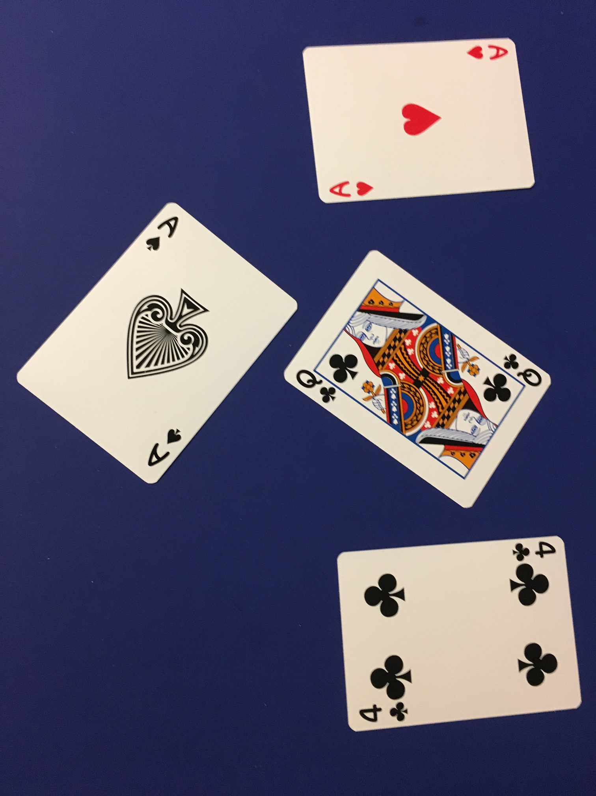

**Original Image**

**The image is converted to greyscale**

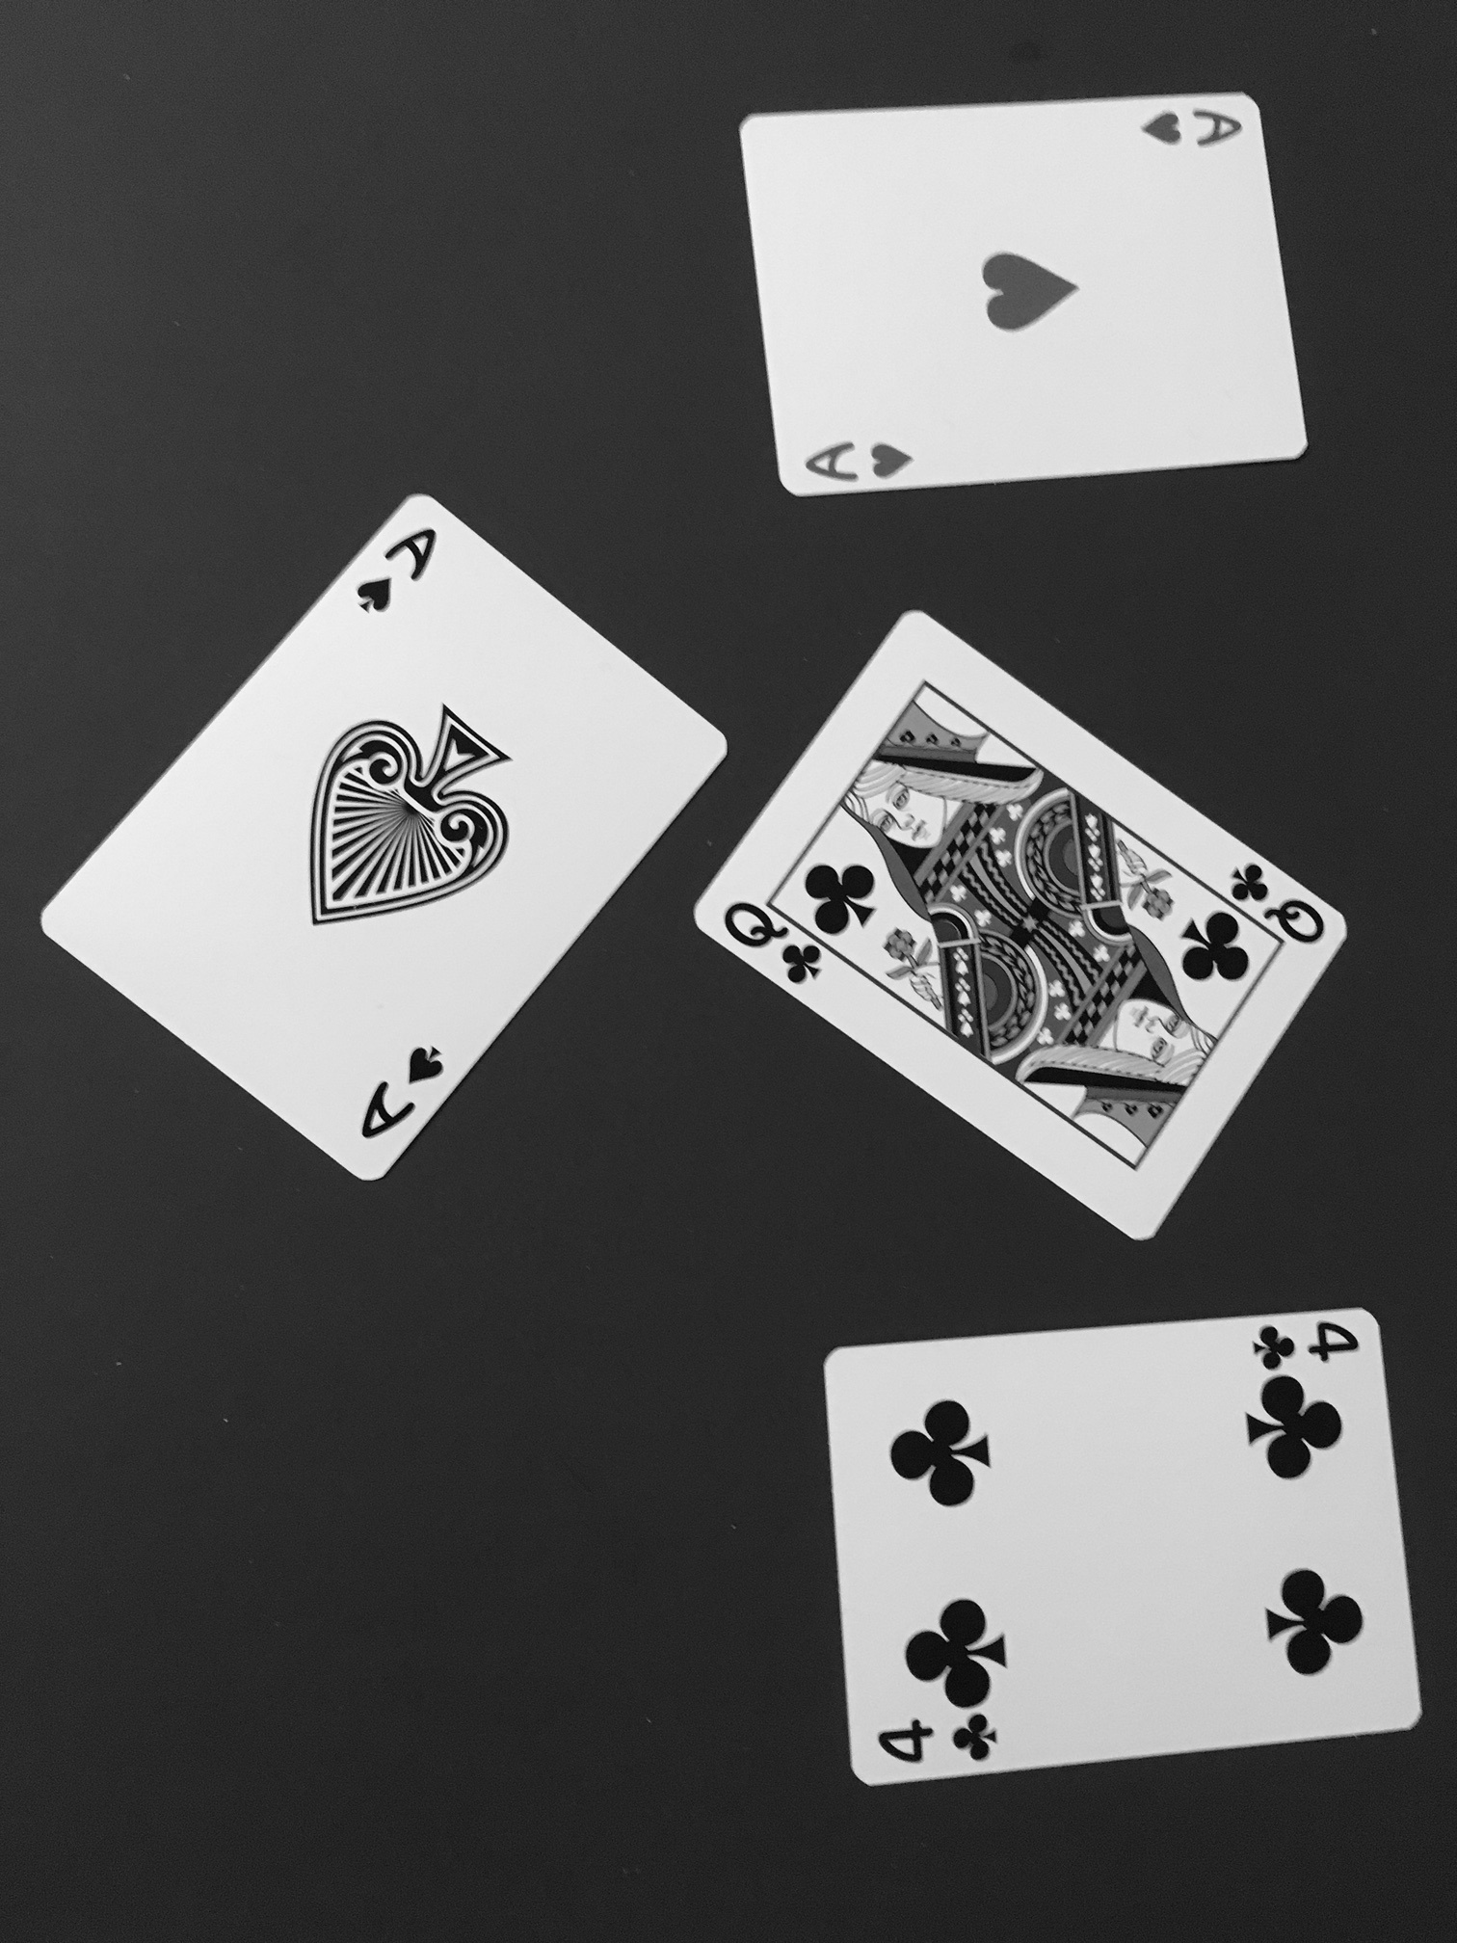

**The image is converted to black or white based on a pixel intensity threshold**

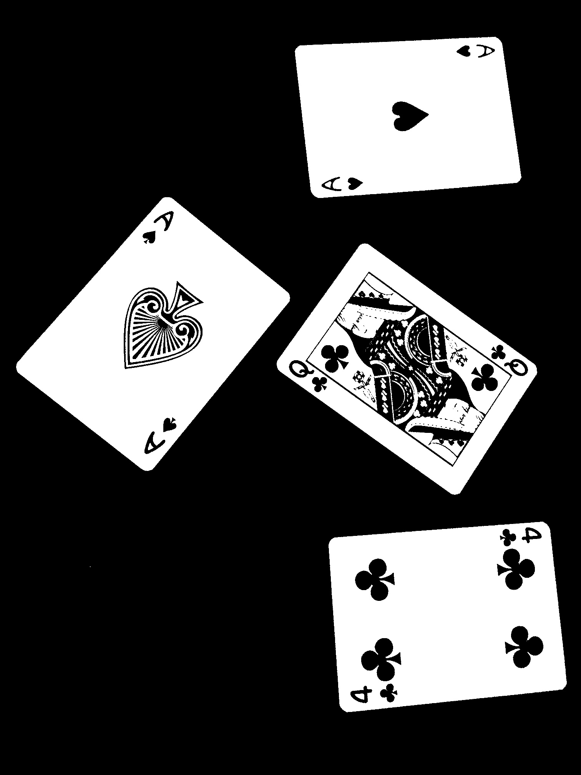

**The images are rotated**

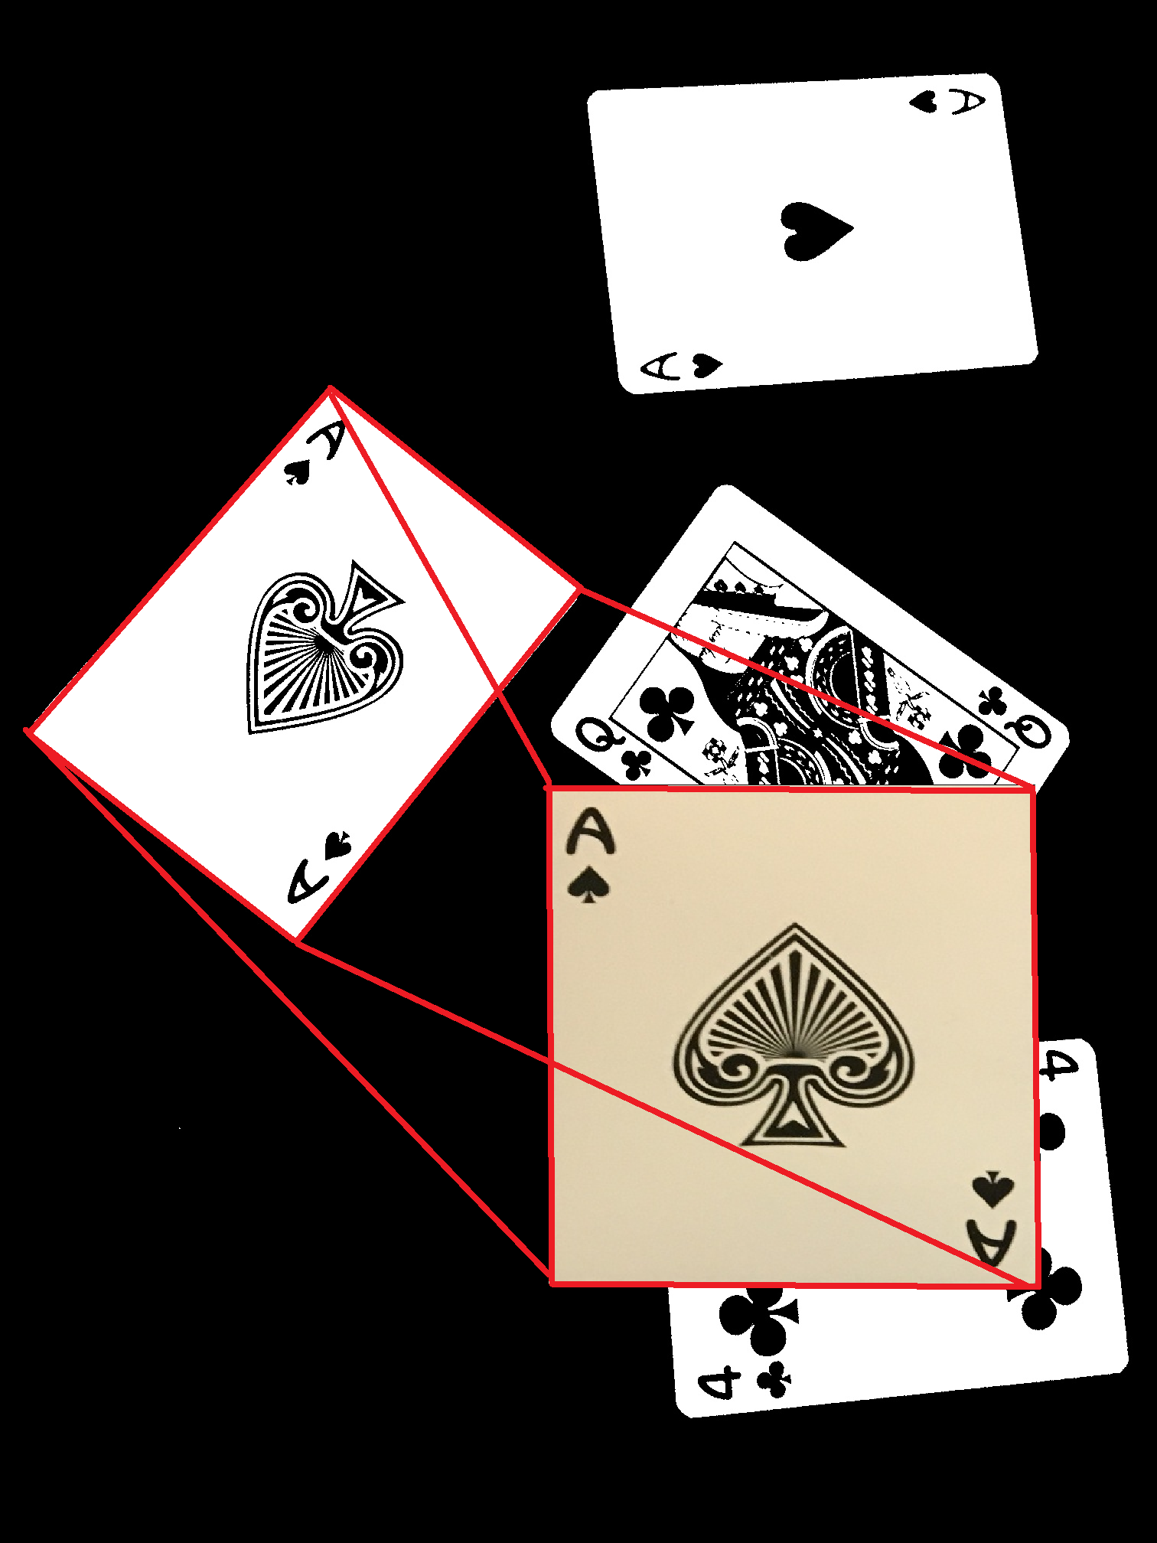

**The images are fed into the tensorflow image classifier (they are also tested at 90 degree rotation) The highest score is the card**

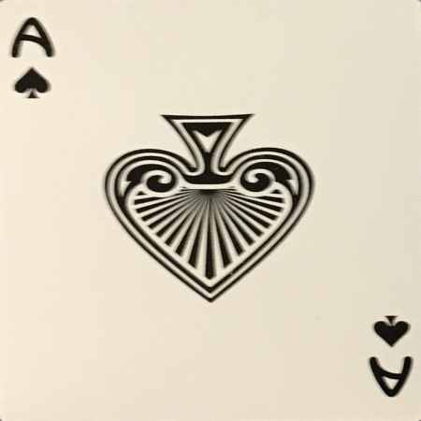 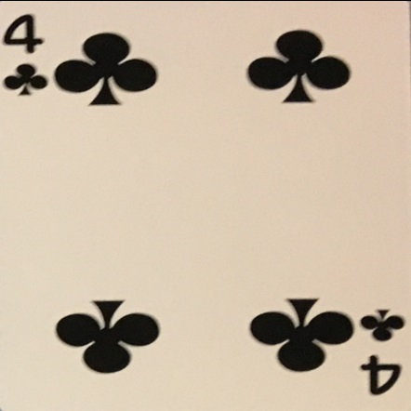 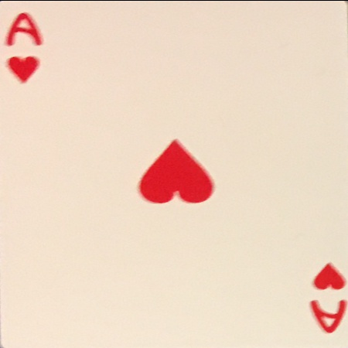

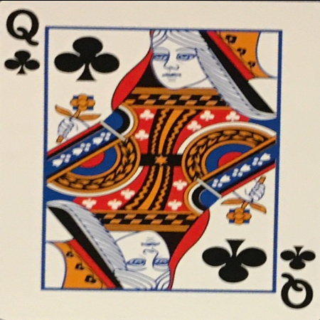

card 0.jpg

**4 clubs (score = 0.53082)**

------------------------------

card 1.jpg

**ace spades (score = 0.91025)**

------------------------------

card 2.jpg

**queen clubs (score = 0.64548)**

------------------------------

card 3.jpg

**ace hearts (score = 0.95669)**